**Front-End UI/UX Development**    
   
   
**Front-End UI/UX Development Mini Project**    
   
   
**UI/UX DESIGN FUNDAMENTALS**

**Submitted by:**

|  |  |  |  |  |
| --- | --- | --- | --- | --- |
| **SR.NO** | **NAME** | **REGISTER**  **NUMBER** | **COLLEGE EMAIL ID** | **CLASS** |
| 1. | JEROLIN MATHEW | 2462331 | jerolin.mathew@btech.christuniversity.in | 3BTCS DS |
| 2. | ADWAITH PRAVEEN | 2462308 | adwaith.praveen@btech.christuniversity.in | 3BTCS DS |
| 3. | PRASANNA R.D | 2462349 | prasanna.rd@btech.christuniversity.in | 3BTCS DS |

**Instructor Name**: Mrs. Nagaveena

**Institution Name:** Christ (Deemed to be University), Bangalore

**Date of Submission:**12/08/2025

**RECIPE BLOG TEMPLATE**

**1.Abstract**

This project is a responsive and visually appealing restaurant landing page designed to showcase dishes, highlight featured recipes, and provide contact options for customers. The site aims to create an engaging first impression for potential visitors by blending modern UI elements, vibrant colour schemes, and easy navigation.

**2.Objectives**

* Create a user-friendly and visually appealing interface for a restaurant.
* Highlight key offerings like featured recipes and menu items.
* Ensure responsiveness across devices.
* Implement intuitive navigation with hover effects.
* Maintain a consistent design theme across multiple pages.

**3.Scope of The Project**

**Included:**

* Homepage with featured recipes and recipe grid.
* Recipe detail section.
* Contact page with a clean form layout.
* Consistent navigation bar and footer styling.
* Hover effects for interactive elements.
* Basic responsiveness for different screen sizes.

**Not Included:**

* Backend integration for form submission.
* Database storage for recipes or user queries.
* Online ordering or payment gateway.
* Advanced animations or third-party API integrations.

**5. Tools & Technologies Used**

* **HTML5** – Structure and semantic content.
* **CSS3** – Styling and hover effects.
* **Flexbox & CSS Grid** – Layout management.
* **Visual Studio Code (VS Code)** – Code editor.
* **Google Chrome** – Primary testing browser.

**6. HTML Structure Overview**

## index.html – Main landing page with navigation, featured section, and recipe grid.

## recipes.html – Displays a selection of recipes in a grid format with hover effects.

## contact.html – Contact form with navigation and footer.

## CSS Files:

## main_style.css – Main landing page styling (navigation, featured section, recipe grid, footer).

## recipe.css – Specific styles for the recipe page.

## contact.css – Styling for the contact page.

## **7. CSS Styling Strategy**

* **Reset Styles:** Applied universal * selector to remove default margins/paddings.
* **Consistent Theme:** Repeated use of brand color #ff7043 for headers, navigation, and buttons.
* **Flexbox:** Used for navigation bars and alignment in headers.
* **CSS Grid:** Implemented for recipe cards to ensure responsiveness.
* **Hover Effects:** Added for interactive feedback (.icon:hover, .btn:hover).
* **Shadows and Borders:** Box shadows for images and recipe cards to create depth.
* **Responsive Widths:** Used vw, vh, and auto-fit grid to adapt layouts.

**8. Key Features**

* **Consistent Navigation Bar:** Styled with hover effects and active state highlights.
* **Featured Recipe Section:** Large image display with accompanying text.
* **Recipe Grid:** Responsive grid layout for showcasing multiple dishes.
* **Contact Page:** Styled header, footer, and form section.
* **Hover Interactions:** Smooth transitions on icons, buttons, and images.
* **Color Theme:** Vibrant orange (#ff7043) with soft cream backgrounds for warmth and appetite stimulation.

**9. Challenges Faced & Solutions**

* **Navigation Alignment Issues**  
  *Solution:* Used flexbox with justify-content and align-items for proper centering.
* **Image Distortion in Recipe Cards**  
  *Solution:* Fixed dimensions and applied border-radius to maintain aspect ratio and style.
* **Inconsistent Hover Behavior**  
  *Solution:* Added transitions and ensured uniform padding/margins across clickable elements.
* **Maintaining Design Consistency Across Pages**  
  *Solution:* Created dedicated CSS files but reused common styles for navigation and footer.

## **10. Outcome**

## A fully functional, responsive landing page for a restaurant.

## Clean and attractive design encouraging user engagement.

## Easy navigation between home, recipes, and contact sections.

## **11. Future Enhancements**

* Add **mobile-specific menu toggle** for better small-screen usability.
* Integrate **backend** to handle contact form submissions.
* Add **animations** for smoother content loading.
* Include **search and filter** functionality for recipes.
* Support **multi-language options** for broader reach.

**12. Screenshots of the Code And Webpage**

main1.html:

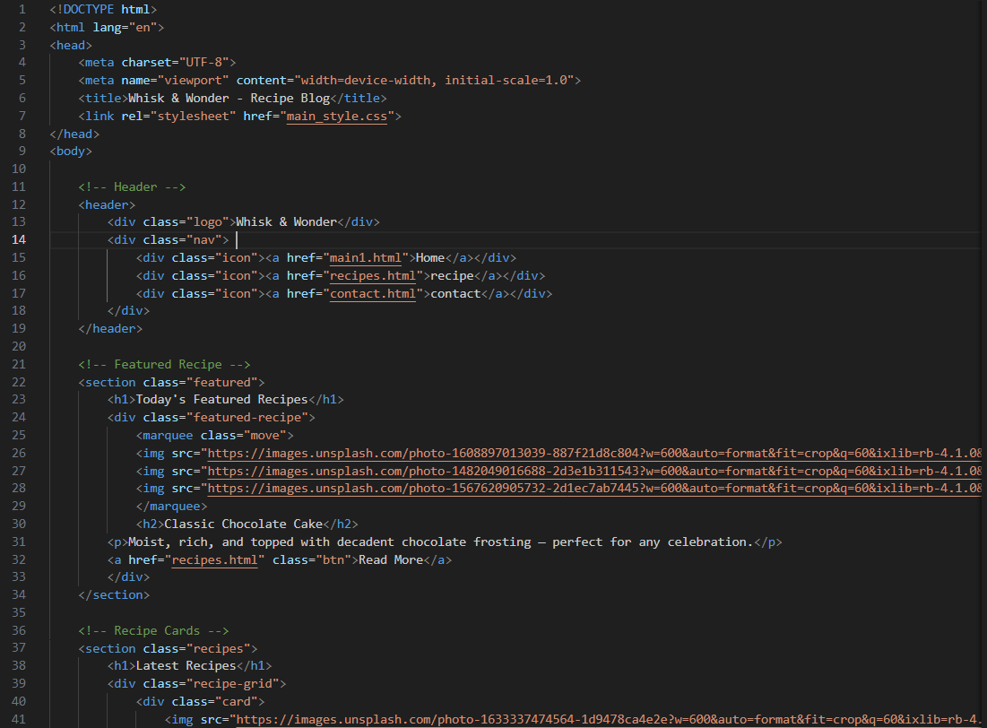

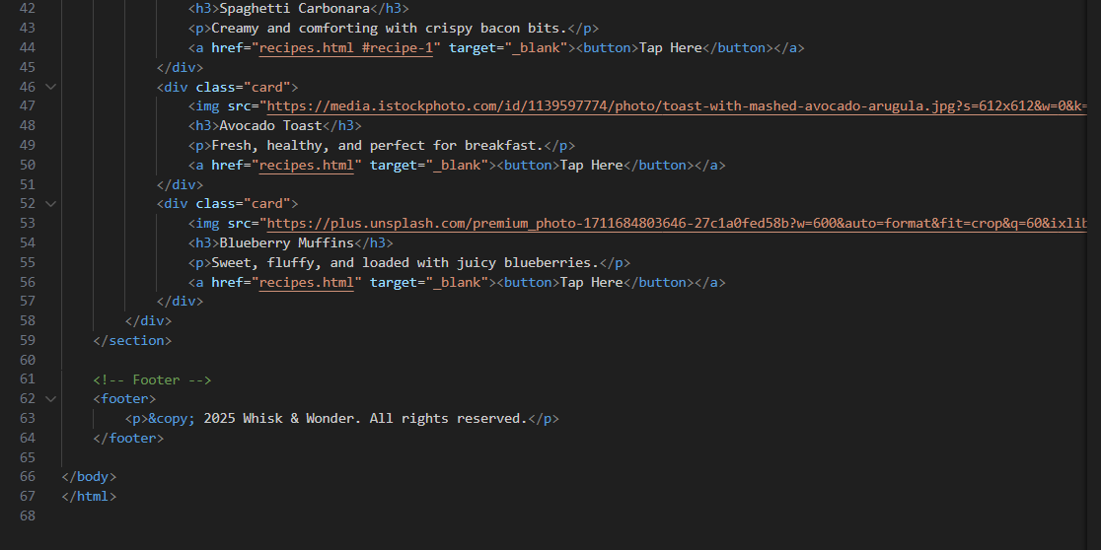

Main_style.css:  
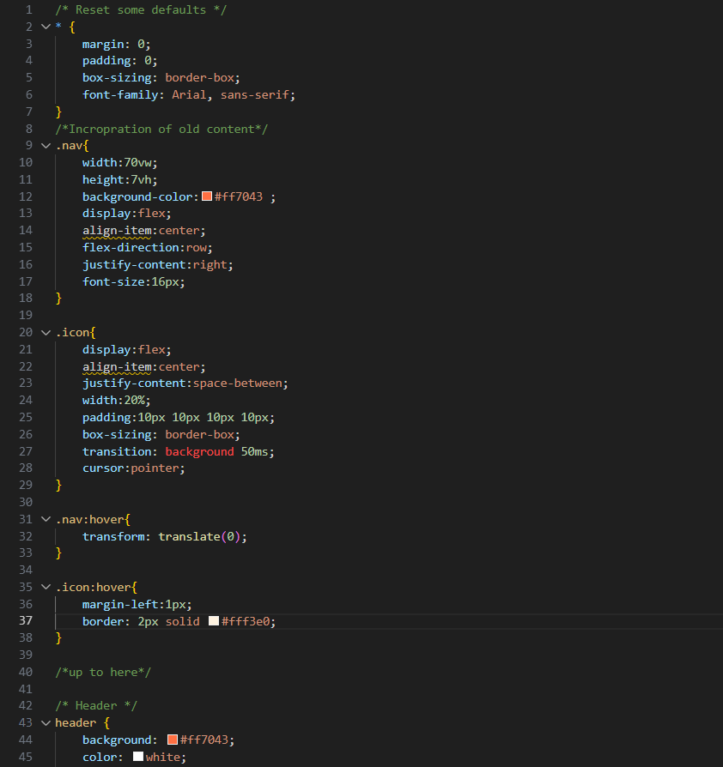

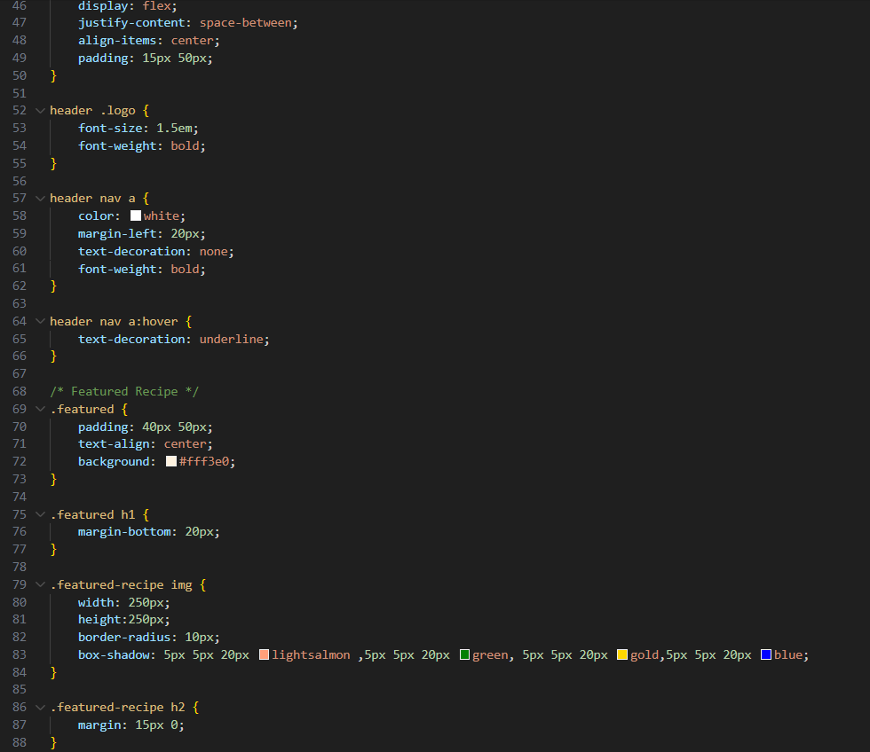

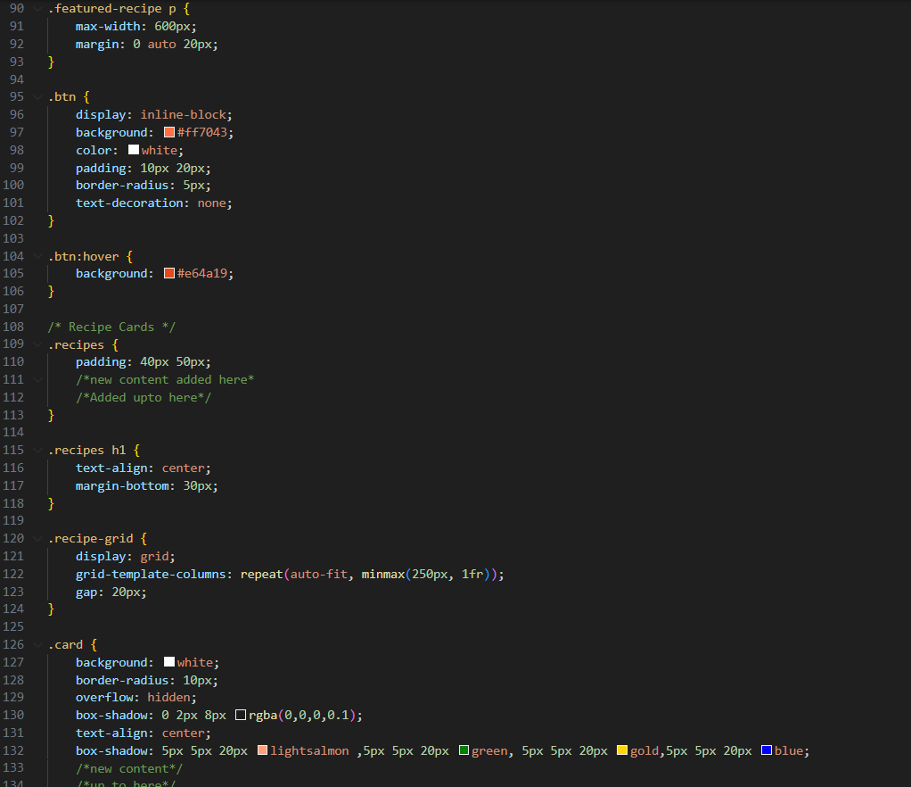

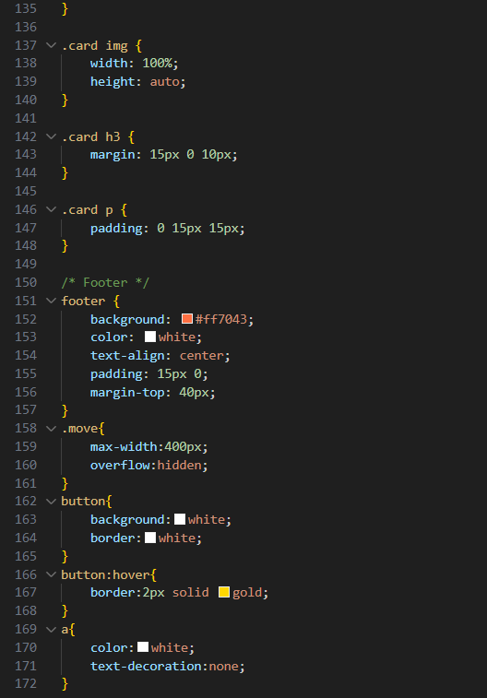

Recipes.html:  
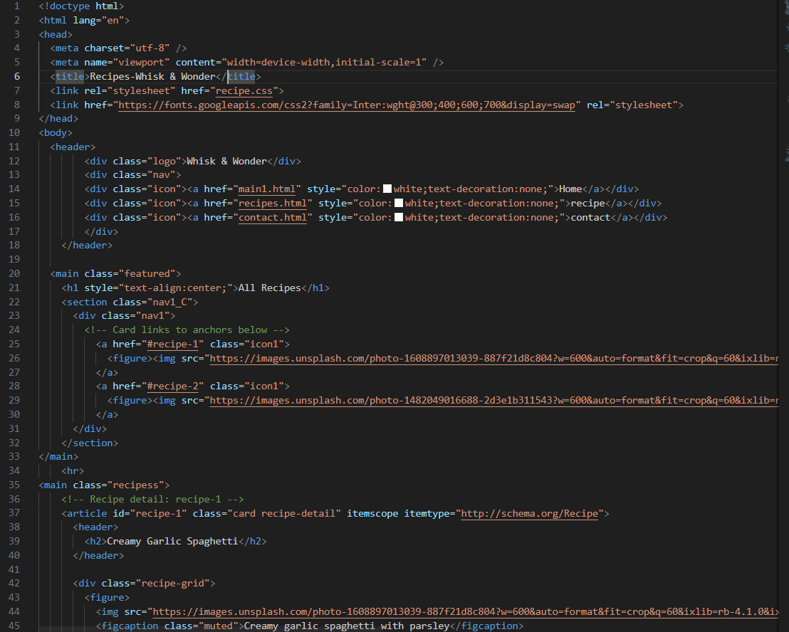

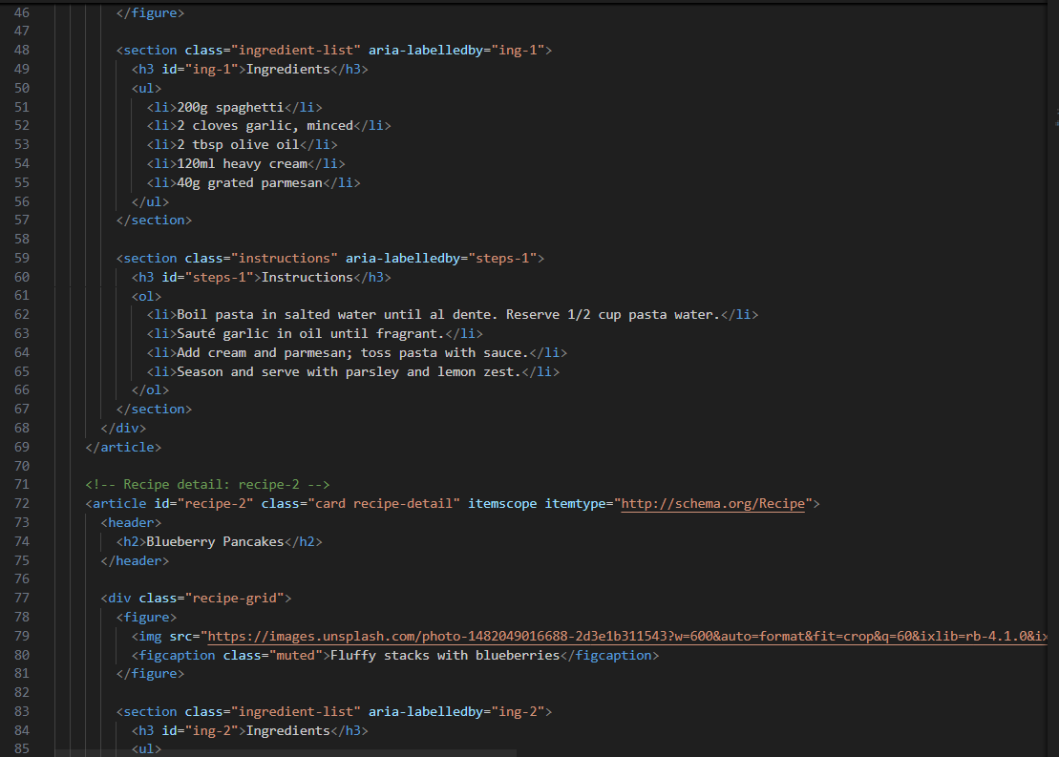

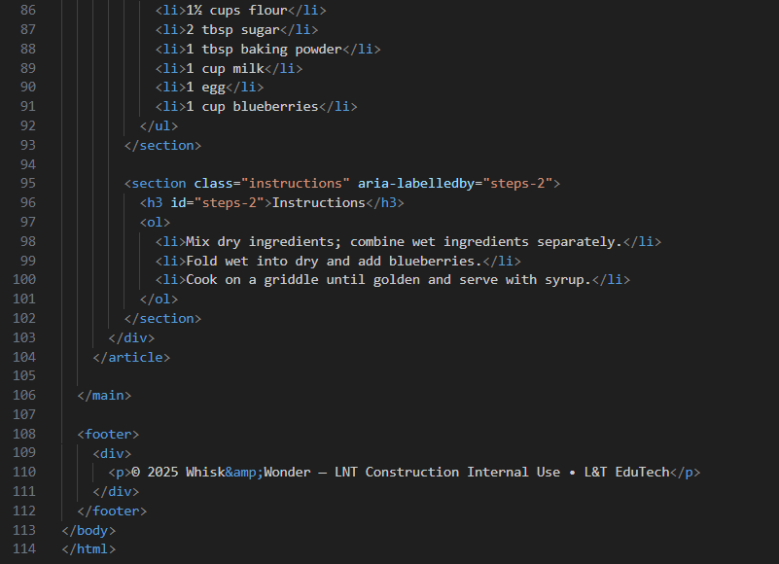

Recipe.css:  
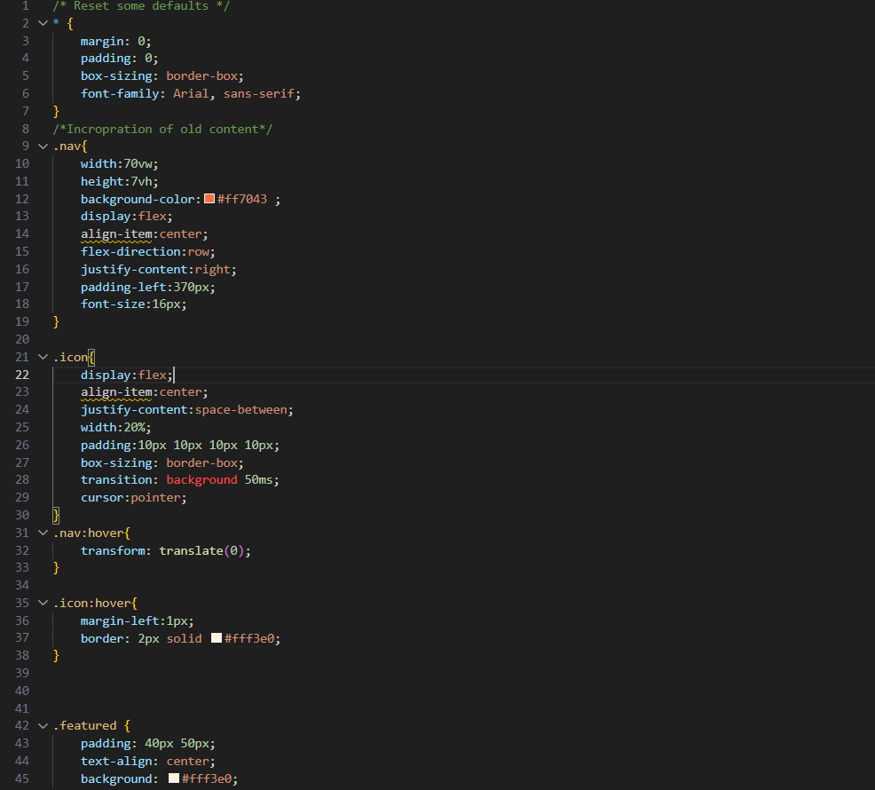

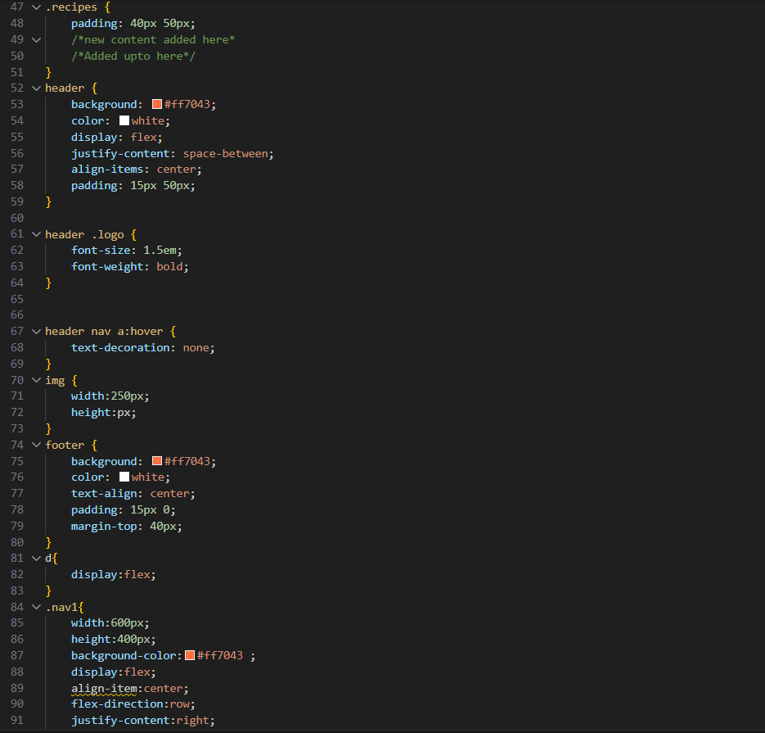

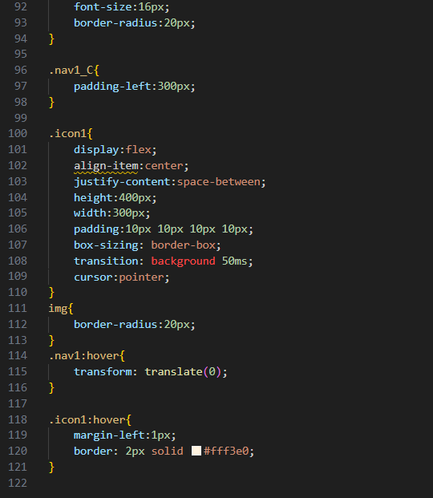

Contact.html:  
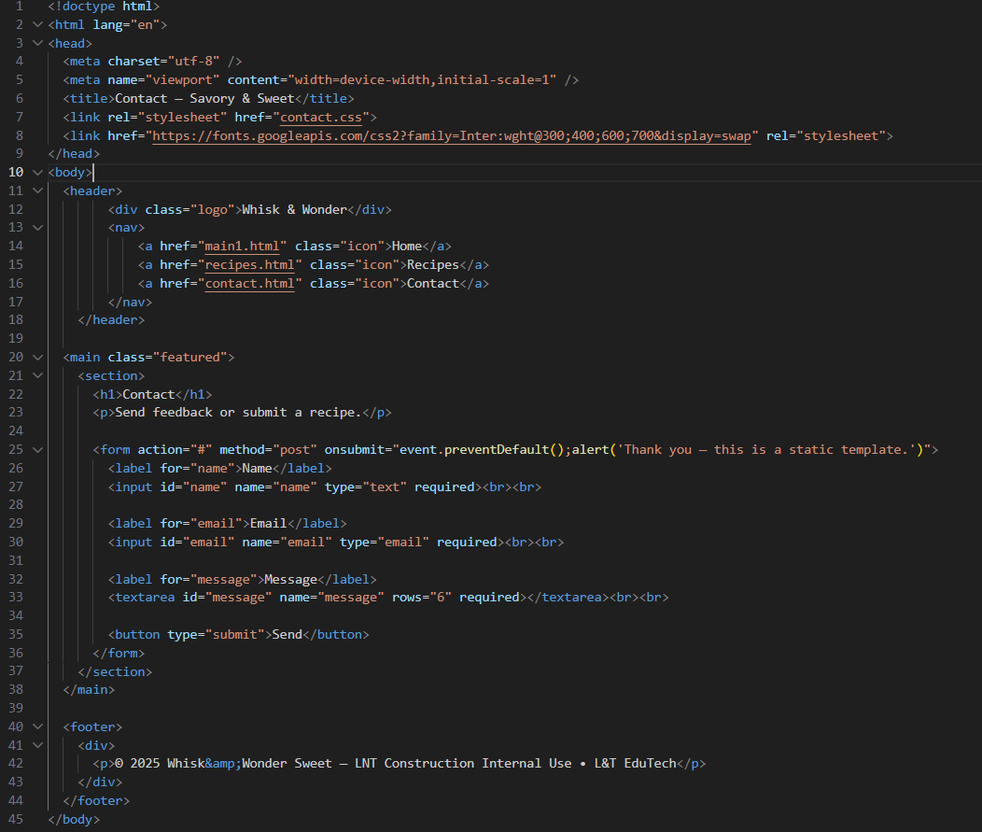

Contact.css:

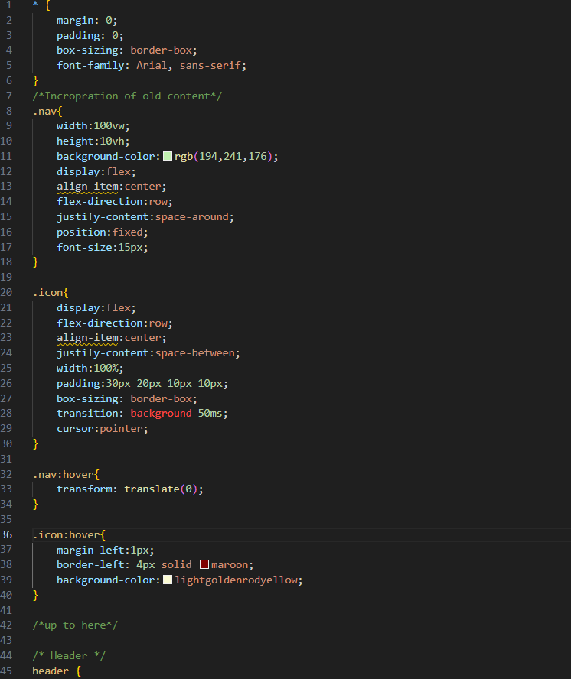

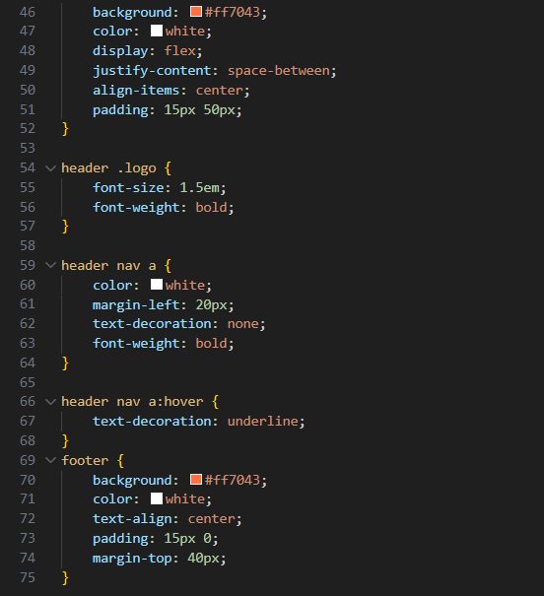

Webpage:  
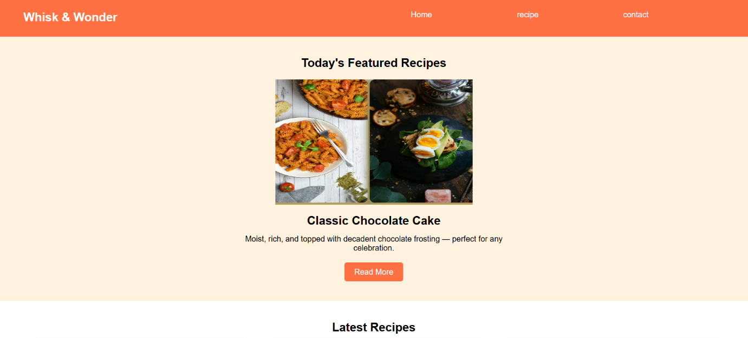

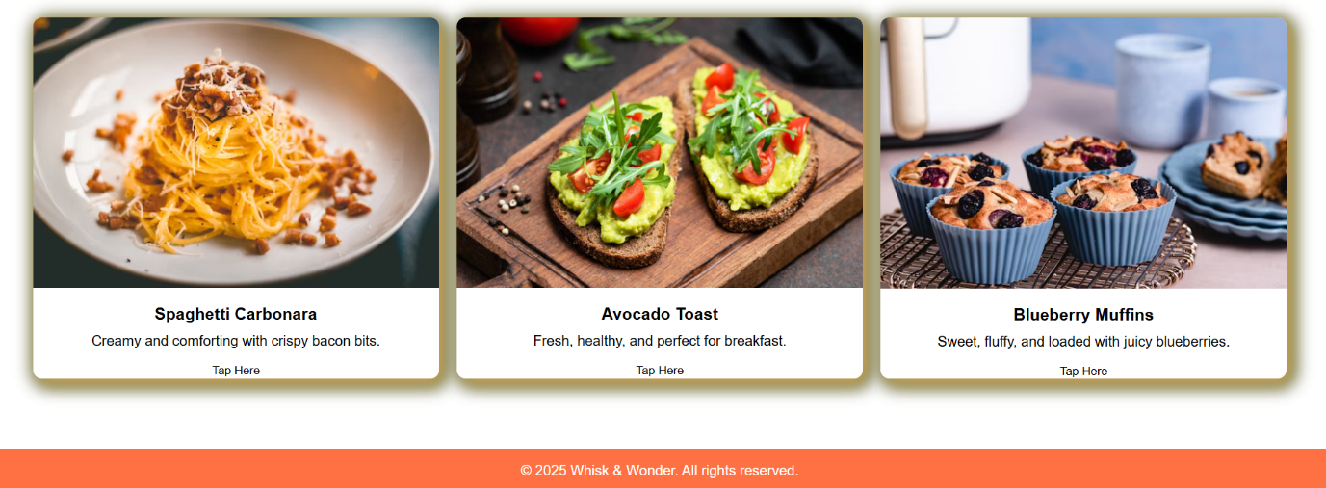

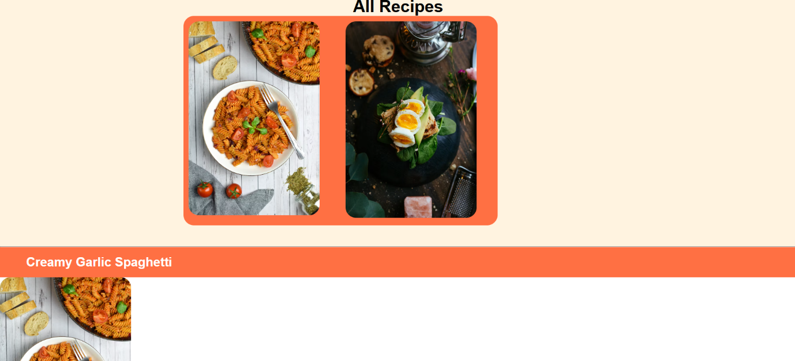

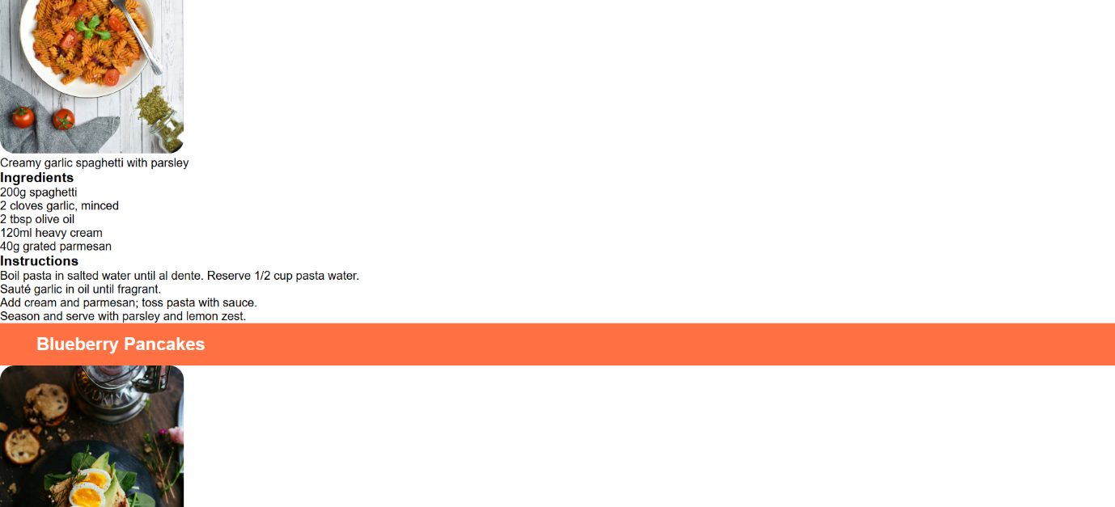

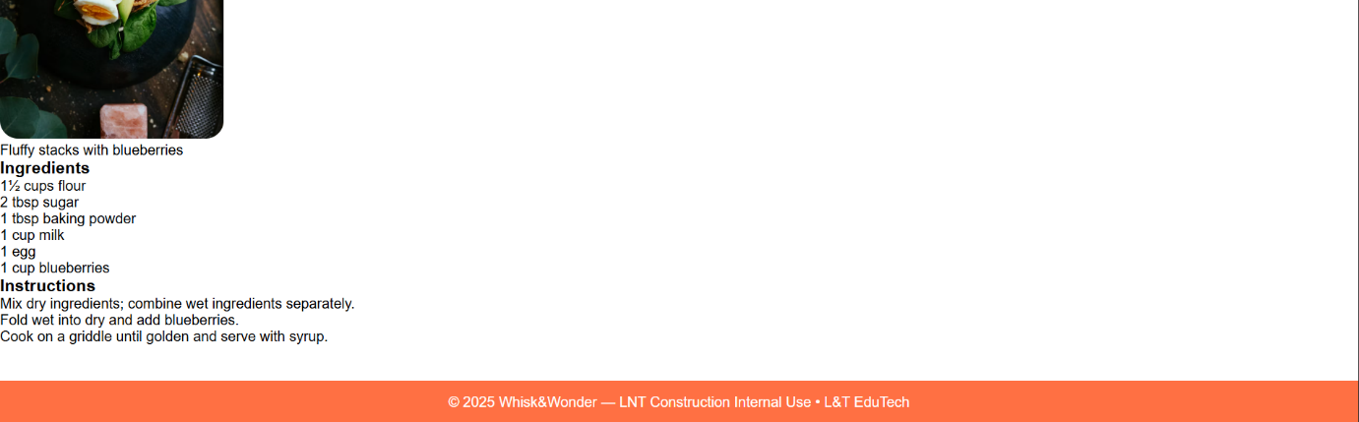

## **13. Conclusion**

This restaurant landing page successfully demonstrates the principles of modern web design: simplicity, responsiveness, and user engagement. The project lays a solid foundation for future enhancements like backend integration and advanced interactive features, while already providing an appealing and functional interface for visitors.